Exploration and Advancement of Drugs Within the Field of Bioinformatics: A Review

Rushikesh Balu Shendage¹, Pramod Chikkodi^{2,}*

Abstract
After selection, research objectives fall under the supervision of either the pharmaceutical industry or pertinent academic institutions. The initial approach involves identifying drug molecules possessing the essential qualities necessary for the synthesis of targeted medications. Drug development constitutes the subsequent phase following the discovery of a drug and unfolds as a meticulous process aimed at introducing novel pharmaceuticals to the market. This intricate journey from discovery to market availability encompasses a substantial timeframe, often spanning two decades. Along this trajectory, the drug development process demands meticulous efforts, rigorous testing, and adherence to regulatory standards. The financial investment involved in this extensive undertaking can amount to a staggering $3 billion before the developed drug is deemed fit for clinical utilization. The pharmaceutical industry and academic institutions play a pivotal role in steering the course of research targets, overseeing the intricate process of drug development. The initial step involves discerning drug molecules endowed with the requisite properties, laying the foundation for subsequent phases. As drugs progress through the intricate stages of development, including pre-clinical and clinical trials, the cumulative investment of time and financial resources becomes evident. Ultimately, this exhaustive process aims to ensure that new drugs, backed by comprehensive research and testing, meet the stringent criteria for safety, efficacy, and regulatory approval before reaching the crucial stage of clinical utilization.

Keywords: Drug discovery; drug development; methods; stages, regulatory

INTRODUCTION
*Author for Correspondence
Pramod Chikkodi
E-mail: pramodchikkodi115@gmail.com

¹Student, Department of Pharmacy, Nootan College of Pharmacy, Kavathe Mahankal, Sangli, Maharashtra, India
²Associate Professor and Head, Department of Pharmaceutics, Kavathe Mahankal, Sangli, Maharashtra, India

Received Date: December 13, 2023
Accepted Date: December 16, 2023
Published Date: December 31, 2023

Citation: Rushikesh Balu Shendage, Pramod Chikkodi. Exploration and Advancement of Drugs Within the Field of Bioinformatics: A Review. Research & Reviews: A Journal of Bioinformatics. 2023; 10(3): 15–21p.
Drug development is the process of introducing new drugs to the market after the identification of lead drugs during drug discovery. It includes preliminary studies in organisms and animals, requests for regulatory approval, such as investigations of new drugs initiated for human trials by the U.S. Food and Drug Administration, and may include steps to obtain approval of a new drug application to market the drug [1, 2]. The entire process of vaccine or drug approval, from concept to preclinical testing and clinical trials (including Phase I-III trials), takes more than a decade [1–4] as seen in Figure 1.

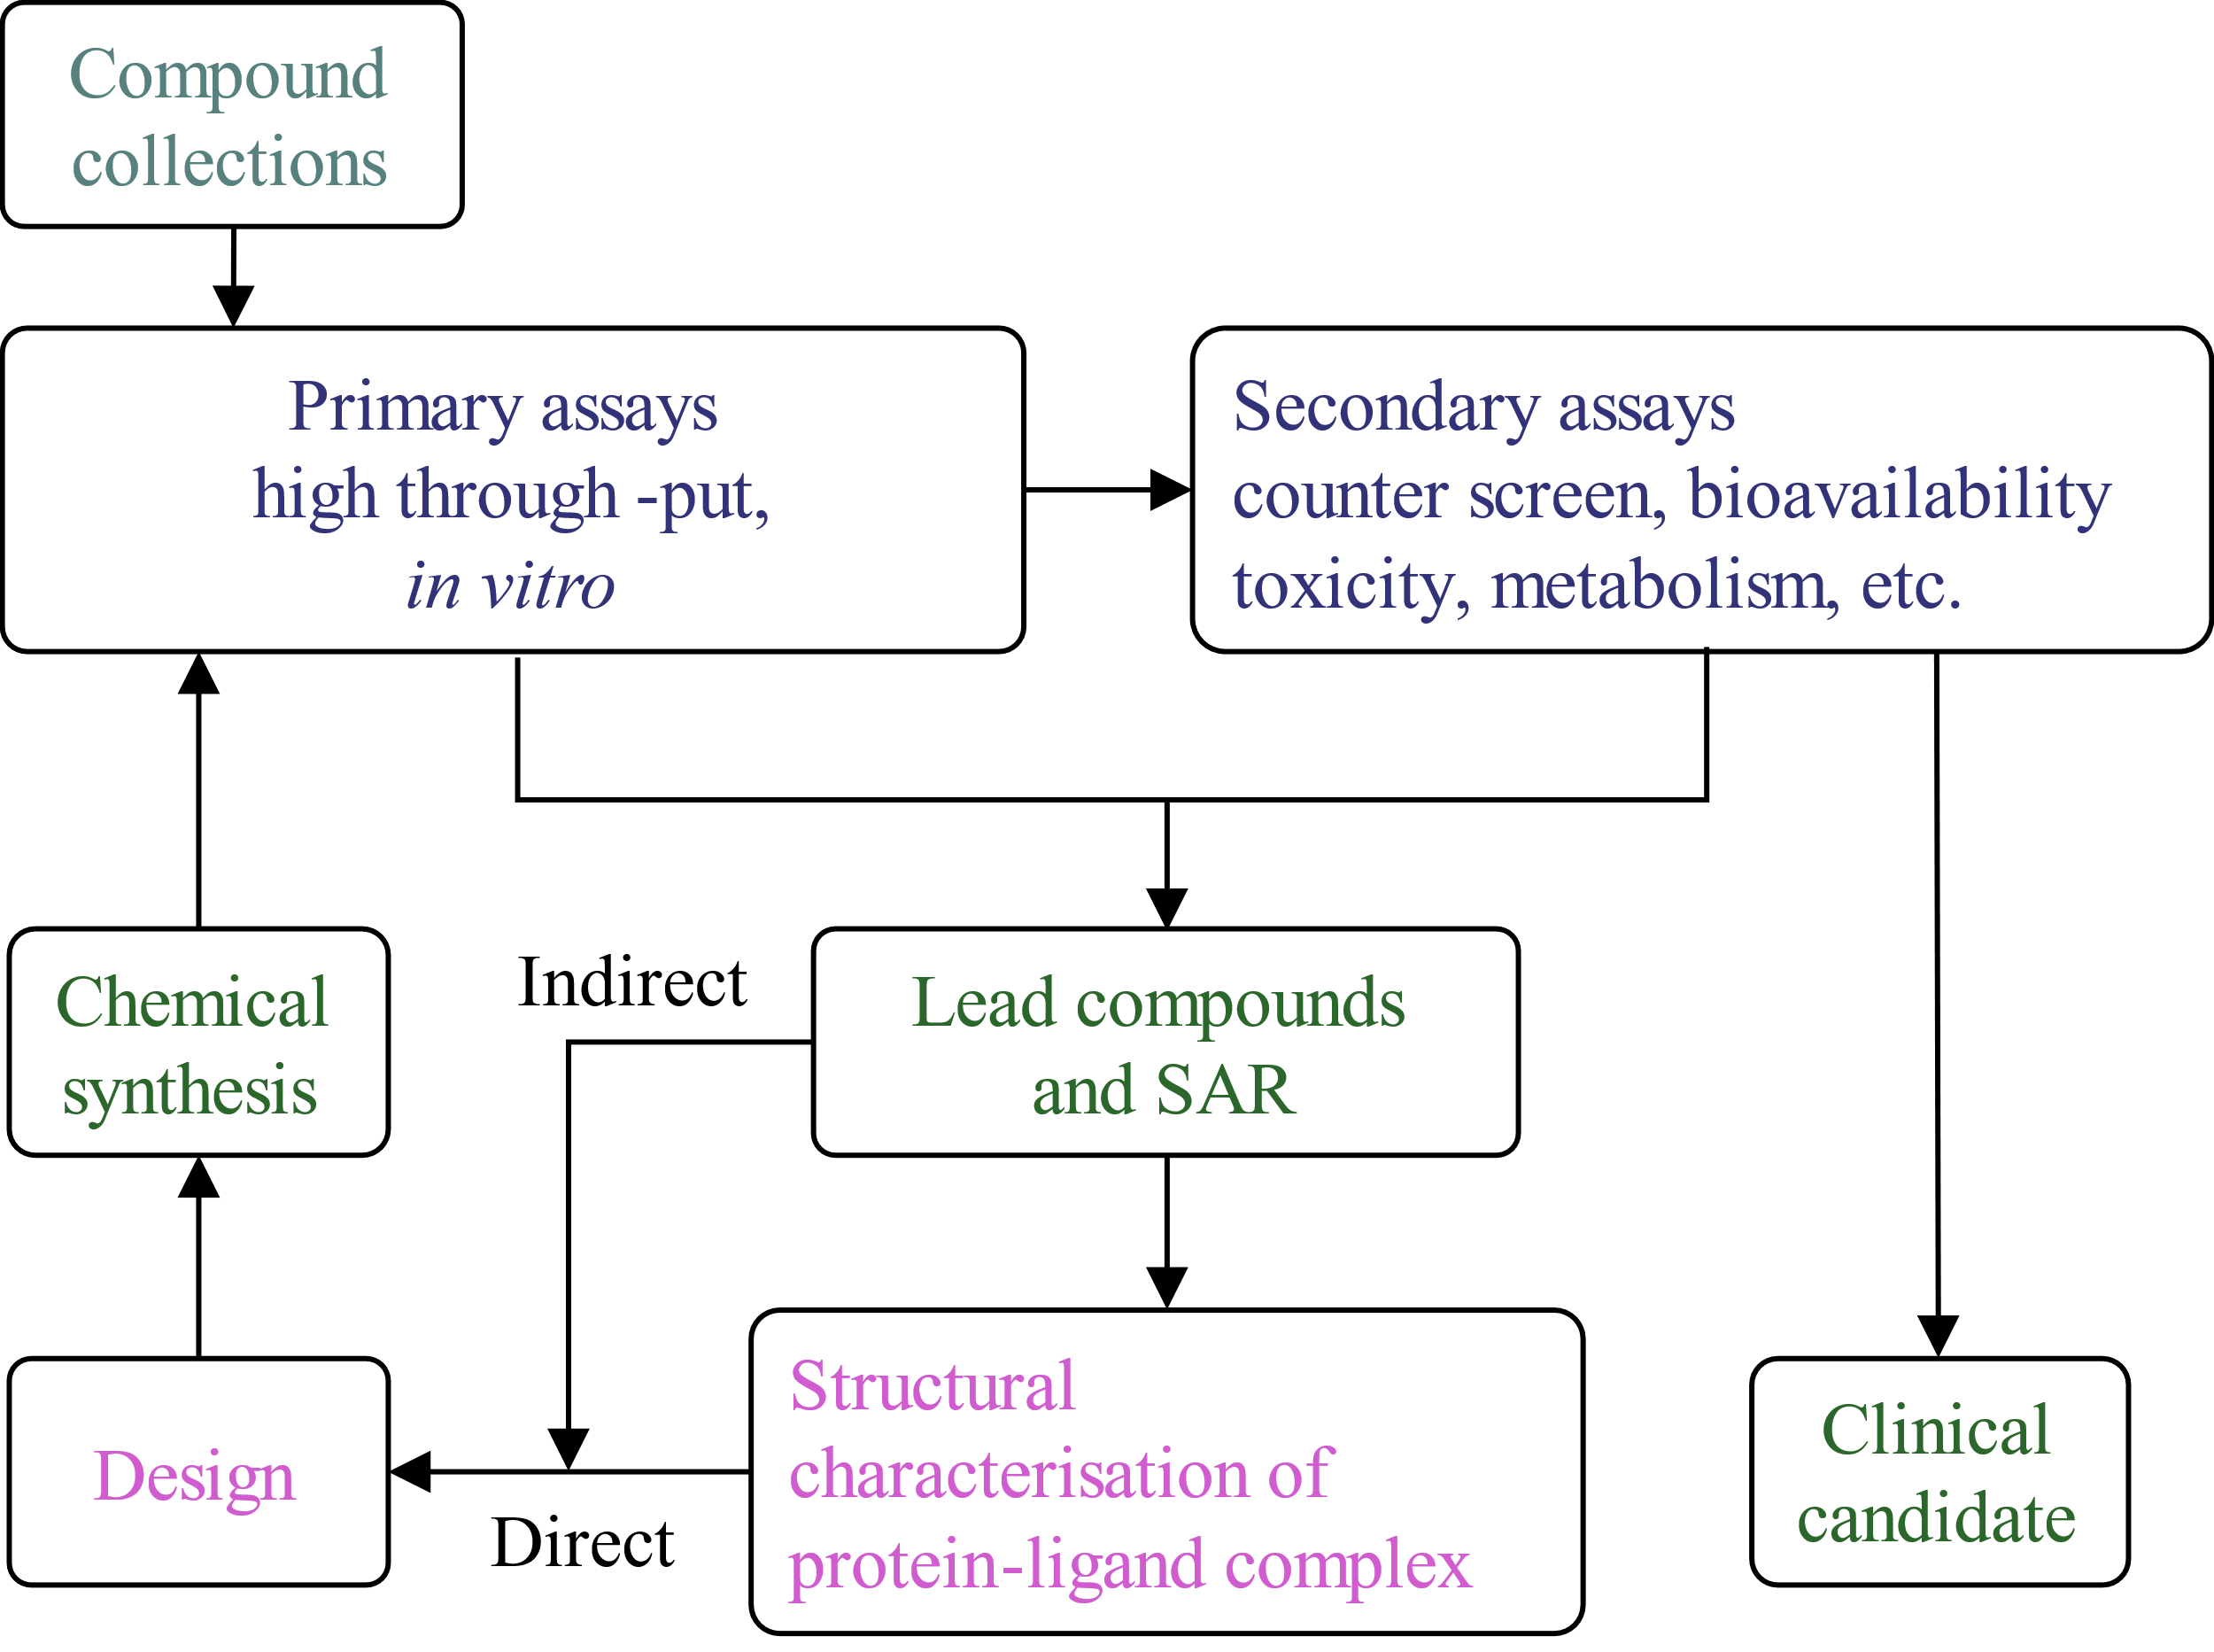
Figure 1. Drug discovery cycle diagram.
Generally speaking, the drug development process can be divided into Preclinical study and Clinical study. A timeline of various drug approvals and research phases [5].

PRECLINICAL
Main article: Preclinical Development
New chemical entities (NCE, also called New molecular entities (also known as (NMEs)) are compounds that have emerged during drug discovery and have promising activity against important biological targets in disease. However, little is known about the safety, toxicity, pharmacokinetics, and metabolism of NCE in humans. It is the responsibility of drug development to evaluate all these parameters before human clinical trials. [FIM]).as seen in Figure 2.

In addition, the physical properties of NCEs should be taken into account in drug development: their chemical composition, stability and solubility. Doctors can treat, measure production from the milligram scale to the kilogram and tonne scale, as well as check whether the products are suitable for packaging such as capsules, tablets, aerosols, intramuscular injections, subcutaneous injections or injections. This process is called chemistry, manufacturing, and controls (CMC) in preclinical and clinical development.

Much of drug development focuses on meeting regulatory requirements for the use of new drugs. These are usually tests designed to determine the toxicity of a new drug before it is used for the first time in humans. The law excludes physical toxicity (effects on the heart and lungs, brain, kidneys, liver, and digestive system) as well as effects on other parts of the body that the drug will affect (for example, if the new drug is used by rubbing or administering to the skin, it is the skin). These preliminary experiments are performed using in vitro methods (e.g. using isolated cells), but in many experiments only experimental animals can be used to demonstrate the interaction between metabolism and chemical utilization [6].

Information from preliminary tests, including CMC data, is collected and submitted to the regulatory agency (FDA in the United States) as an Investigational New Drug (IND) application. If the IND is approved, development will advance to the clinical phase.

CLINICAL PHASES
Clinical trials have four steps [7]:
- Phase 1: Designed trials are generally conducted on employee health and safety and medication decisions.
- Phase II: Trials are used to get an initial reading of efficacy and further explore safety in small numbers of patients having the disease targeted by the NCE.
- Phase III: A trial is a large clinical study designed to determine safety and effectiveness in patients with sufficient disease. Trial is a large clinical study designed to determine safety and effectiveness in patients with sufficient disease. If safety and efficacy are adequately proved, clinical testing may stop at this step and the NCE advances to the new drug application (NDA) stage.
- Phase IV: Trials are post-approval trials that are sometimes a condition attached by the FDA, also called post-market surveillance studies.

The process of defining characteristics of the drug does not stop once an NCE is advanced into human clinical trials. In addition to the tests required to move a novel vaccine or antiviral drug into the clinic for the first time, manufacturers must ensure that any long-term or chronic toxicities are well-defined, including effects on systems not previously monitored (fertility, reproduction, immune system, among others) [8, 9].

If a vaccine candidate or antiviral compound emerges from these tests with an acceptable toxicity and safety profile, and the manufacturer can further show it has the desired effect in clinical trials, then the NCE portfolio of evidence can be submitted for marketing approval in the various countries where the manufacturer plans to sell it [4]. In the United States, this process is called a “new drug application” or NDA [4, 8].
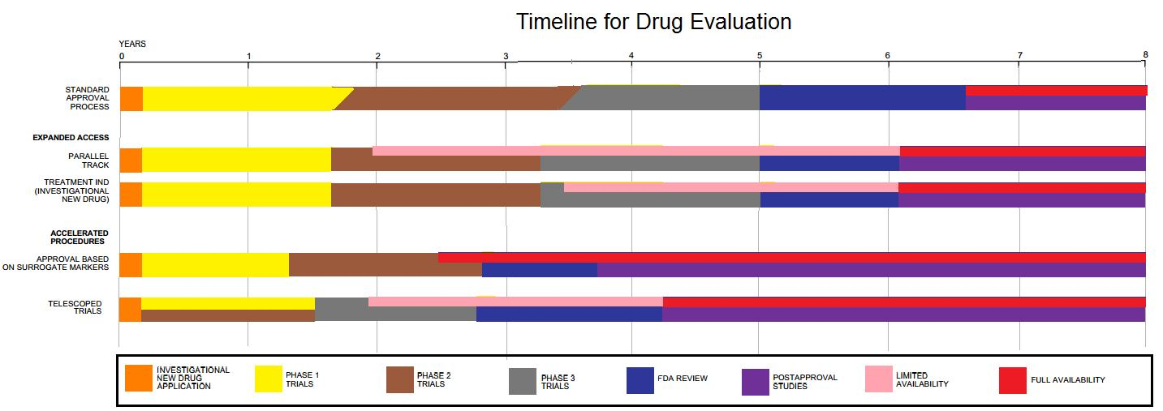
Figure 2. New chemical entity development.
Most novel drug candidates (NCEs) fail during drug development, either because they have unacceptable toxicity or because they simply do not prove efficacy on the targeted disease, as shown in Phase II–III clinical trials [4, 8]. Critical reviews of drug development programs indicate that Phase II–III clinical trials fail due mainly to unknown toxic side effects (50% failure of Phase II cardiology trials), and because of inadequate financing, trial design weaknesses, or poor trial execution [10, 11].

A study covering clinical research in the 1980–90s found that only 21.5% of drug candidates that started Phase I trials were eventually approved for marketing [12]. During 2006–15, the success rate of obtaining approval from Phase I to successful Phase III trials was under 10% on average, and 16% specifically for vaccines [13]. The high failure rates associated with

COST
Main article: Cost of drug development
One 2010 study assessed both capitalized and out-of-pocket costs for bringing a single new drug to market was about US$1.8 billion and $870 million, respectively [15]. A median cost estimate of 2015–16 trials for development of 10 anti-cancer drugs was $648 million [16]. In 2017, the median cost of a pivotal trial across all clinical indications was $19 million [17].

The average cost (2013 dollars) of each stage of clinical research was US$25 million for a Phase I safety study, $59 million for a Phase II randomized controlled efficacy study, and $255 million for a pivotal Phase III trial to demonstrate its equivalence or superiority to an existing approved drug [18], possibly as high as $345 million [17]. The average cost of conducting a 2015–16 pivotal Phase III trial on an infectious disease drug candidate was $22 million [17].

In a 2016 review of 106 drug candidates assessed through clinical trials, the total capital expenditure for a manufacturer having a drug approved through successful Phase III trials was $2. 6 billion (in 2013 dollars), an amount increasing at an annual rate of 8.5% [18]. Over 2003–2013 for companies that approved 8–13 drugs, the cost per drug could rise to as high as $5.5 billion, due [19, 20] mainly to international geographic expansion for marketing and ongoing costs for Phase IV trials for continuous safety surveillance [21].

Alternatives to conventional drug development have the objective for universities, governments, and the pharmaceutical industry to collaborate and optimize resources [22]. An example of a collaborative drug development initiative is COVID Moonshot, an international open-science project started in March 2020 with the goal of developing an un-patented oral antiviral drug to treat SARS-CoV-2 [23, 24].

Valuation
The nature of a drug development project is characterised by high attrition rates, large capital expenditures, and long timelines. This is a task that complicates the costs of projects and companies. Not all measurement methods can cope with these characteristics. The most commonly used metrics are risk-adjusted net present value (rNPV), decision trees, real options, or benchmark models.

The most important cost is the sales estimate, including the cost of capital or features such as the discount rate used, time, cost of completion, and cost of goods sold and sales and selling expenses. Fewer objectives, such as good governance or new technology, should be considered in financial projections [25, 26].

Success Rate
New Drug Candidates Theoretically, 5,000 to 10,000 compounds may be needed to treat the disease. On average, about 250 of these have been shown to be promising enough for further evaluation through laboratory testing, mice, and other experimental animals. Typically, about ten of these qualify for tests on humans [27]. A study conducted by the Tufts Center for the Study of Drug Development covering the 1980s and 1990s found that only 21.5% of drugs that started Phase I trials were eventually approved for marketing [28]. In the time period of 2006 to 2015, the success rate was 9.6% [29]. The high failure rates associated with pharmaceutical development are referred to as the “attrition rate” problem. Careful decision making during drug development is essential to avoid costly failures [30]. In many cases, intelligent programme and clinical trial design can prevent false negative results. Well-designed, dose-finding studies and comparisons against both a placebo and a gold-standard treatment arm play a major role in achieving reliable data [31].

Computing Initiatives
Novel initiatives include partnering between governmental organizations and industry, such as the European Innovative Medicines Initiative [32]. The US Food and Drug Administration created the “Critical Path Initiative” to enhance innovation of drug development [33], and the Breakthrough Therapy designation to expedite development and regulatory review of candidate drugs for which preliminary clinical evidence shows the drug candidate may substantially improve therapy for a serious disorder [34].

In March 2020, the United States Department of Energy, National Science Foundation, NASA, industry, and nine universities pooled resources to access supercomputers from IBM, combined with cloud computing resources from Hewlett Packard Enterprise, Amazon, Microsoft, and Google, for drug discovery [35, 36]. The COVID-19 High Performance Computing Consortium also aims to forecast disease spread, model possible vaccines, and screen thousands of chemical compounds to design a COVID-19 vaccine or therapy [35–37]. In May 2020, the OpenPandemics – COVID-19 partnership between Scripps Research and IBM’s World Community Grid was launched. The partnership is a distributed computing project that “will automatically run a simulated experiment in the background (of connected home PCs) which will help predict the effectiveness of a particular chemical compound as a possible treatment for COVID-19” [38].

CONCLUSION
Nowadays, when diseases are emerging, new drugs are an important part of medicine. A few years ago, conditions such as peptic ulcers were an indication for major surgery [98]. The emergence of new treatments and the introduction of new drugs have reduced the serious problems of peptic ulcers. The situation of HIV patients has also improved due to the emergence of many new antiretroviral drugs. Physicians need to understand drug discovery and development [99]. Understanding these processes can foster innovation, help clinicians evaluate new products, highlight the importance of adverse events, and provide information to clinicians. It can help patients in phase 2 (clinical studies) clinical trials.

REFERENCES
- Strovel J, Sittampalam S, Coussens NP, Hughes M, Inglese J, Kurtz A, et al. (July 1, 2016). "Early Drug Discovery and Development Guidelines: For Academic Researchers, Collaborators, and Start-up Companies". Assay Guidance Manual. Eli Lilly & Company and the National Center for Advancing Translational Sciences. PMID 22553881.
- Jump up to:a b Taylor D (2015). "The Pharmaceutical Industry and the Future of Drug Development". Issues in Environmental Science and Technology. Royal Society of Chemistry: 1–33. doi:10.1039/9781782622345-00001. ISBN 978-1-78262-189-8.
- Everts, Maaike; Cihlar, Tomas; Bostwick, J. Robert; Whitley, Richard J. (6 January 2017). "Accelerating Drug Development: Antiviral Therapies for Emerging Viruses as a Model". Annual Review of Pharmacology and Toxicology. 57 (1): 155–169. doi:10.1146/annurev-pharmtox-010716-104533. ISSN 0362-1642. PMID 27483339. Retrieved 2 November2021.
- Jump up to:a b c d "The Drug Development Process". U.S. Food and Drug Administration (FDA). 4 January 2018. Retrieved 21 March 2020.
- Kessler DA, Feiden KL (March 1995). "Faster evaluation of vital drugs". Scientific American. 272 (3): 48–54. Bibcode:1995SciAm.272c..48K. doi:10.1038/scientificamerican0395-48. PMID 7871409.
- Madorran E, Stožer A, Bevc S, Maver U (2020). "In vitro toxicity model: Upgrades to bridge the gap between preclinical and clinical research". Bosnian Journal of Basic Medical Sciences. 20 (2): 157–68. doi:10.17305/bjbms.2019.4378. PMC 7202182. PMID 31621554.
- Ciociola AA, Cohen LB, Kulkarni P (May 2014). "How drugs are developed and approved by the FDA: current process and future directions". The American Journal of Gastroenterology. 109 (5): 620–3. doi:10.1038/ajg.2013.407. PMID 24796999. S2CID 205100166.
- Jump up to:a b c d Strovel J, Sittampalam S, Coussens NP, Hughes M, Inglese J, Kurtz A, et al. (July 1, 2016). "Early Drug Discovery and Development Guidelines: For Academic Researchers, Collaborators, and Start-up Companies". Assay Guidance Manual. Eli Lilly & Company and the National Center for Advancing Translational Sciences. PMID 22553881.
- "Vaccine Product Approval Process". U.S. Food and Drug Administration (FDA). 30 January 2018. Retrieved 21 March 2020.
- Van Norman GA (June 2019). "Phase II Trials in Drug Development and Adaptive Trial Design". JACC. Basic to Translational Science. 4 (3): 428–437. doi:10.1016/j.jacbts.2019.02.005. PMC 6609997. PMID 31312766.
- Fogel DB (September 2018). "Factors associated with clinical trials that fail and opportunities for improving the likelihood of success: A review". Contemporary Clinical Trials Communications. 11: 156–164. doi:10.1016/j.conctc.2018.08.001. PMC 6092479. PMID 30112460.
- "R&D costs are on the rise". Medical Marketing and Media. 38 (6): 14. June 1, 2003. Archived from the original on October 18, 2016.
- Jump up to:a b "Clinical development success rates: 2006–2015" (PDF). BIO Industry Analysis. June 2016.
- Wang Y (2012). "Extracting knowledge from failed development programmes". Pharmaceutical Medicine. 26 (2): 91–96. doi:10.1007/BF03256897. S2CID 17171991.
- Paul SM, Mytelka DS, Dunwiddie CT, Persinger CC, Munos BH, Lindborg SR, Schacht AL (March 2010). "How to improve R&D productivity: the pharmaceutical industry's grand challenge". Nature Reviews. Drug Discovery. 9 (3): 203–14. doi:10.1038/nrd3078. PMID 20168317. S2CID 1299234.
- Prasad V, Mailankody S (November 2017). "Research and Development Spending to Bring a Single Cancer Drug to Market and Revenues After Approval". JAMA Internal Medicine. 177 (11): 1569–1575. doi:10.1001/jamainternmed.2017.3601. PMC 5710275. PMID 28892524.
- Jump up to:a b c d Moore TJ, Zhang H, Anderson G, Alexander GC (November 2018). "Estimated Costs of Pivotal Trials for Novel Therapeutic Agents Approved by the US Food and Drug Administration, 2015-2016". JAMA Internal Medicine. 178 (11): 1451–1457. doi:10.1001/jamainternmed.2018.3931. PMC 6248200. PMID 30264133.
- Jump up to:a b DiMasi JA, Grabowski HG, Hansen RW (May 2016). "Innovation in the pharmaceutical industry: New estimates of R&D costs". Journal of Health Economics. 47: 20–33. doi:10.1016/j.jhealeco.2016.01.012. hdl:10161/12742. PMID 26928437.
- Taylor D (2015). "The Pharmaceutical Industry and the Future of Drug Development". Issues in Environmental Science and Technology. Royal Society of Chemistry: 1–33. doi:10.1039/9781782622345-00001. ISBN 978-1-78262-189-8.
- Sertkaya A, Wong HH, Jessup A, Beleche T (April 2016). "Key cost drivers of pharmaceutical clinical trials in the United States". Clinical Trials. 13 (2): 117–26. doi:10.1177/1740774515625964. PMID 26908540. S2CID 24308679.
- Herper M (11 August 2013). "The cost of creating a new drug now $5 billion, pushing Big Pharma to change". Forbes. Retrieved 17 July 2016.
- Maxmen A (August 2016). "Busting the billion-dollar myth: how to slash the cost of drug development". Nature. 536 (7617): 388–90. Bibcode:2016Natur.536.388M. doi:10.1038/536388a. PMID 27558048.
- Whipple, Tom (October 23, 2021). "Moonshot is the spanner in the Covid-19 works the country needs". The Times. Retrieved 5 November 2021.
- Lee, Alpha; Chodera, John; von Delft, Frank (27 September 2021). "Why we are developing a patent-free Covid antiviral therapy". Knowable Magazine. doi:10.1146/knowable-092721-1. S2CID 244170138. Retrieved 1 November 2021.
- Boris Bogdan and Ralph Villiger, "Valuation in Life Sciences. A Practical Guide", 2008, 2nd edition, Springer Verlag.
- Nielsen, Nicolaj Hoejer "Financial valuation methods for biotechnology", 2010. "Archived copy" (PDF). Archived from the original(PDF) on 2012-03-05. Retrieved 2014-11-25.
- Stratmann HG (September 2010). "Bad Medicine: When Medical Research Goes Wrong". Analog Science Fiction and Fact. CXXX (9): 20.
- "R&D costs are on the rise". Medical Marketing and Media. 38 (6): 14. June 1, 2003. Archived from the original on October 18, 2016.
- "Clinical Development Success Rates 2006-2015" (PDF). BIO Industry Analysis. June 2016.
- Wang Y. (2012). "Extracting Knowledge from Failed Development Programmes". Pharm Med. 26 (2): 91–96. doi:10.1007/BF03256897. S2CID 17171991.
- Herschel, M. (2012). "Portfolio Decisions in Early Development: Don't Throw Out the Baby with the Bathwater". Pharm Med. 26 (2): 77–84. doi:10.1007/BF03256895. S2CID 15782597. Archived from the original on 2012-06-16. Retrieved 2012-06-12.
- "About the Innovative Medicines Initiative". European Innovative Medicines Initiative. 2020. Retrieved 24 January 2020.
- "Critical Path Initiative". US Food and Drug Administration. 23 April 2018. Retrieved 24 January 2020.
- "Breakthrough Therapy". US Food and Drug Administration. 4 January 2018. Retrieved 24 January 2020.
- Jump up to:a b Shankland S (2020-03-23). "Sixteen supercomputers tackle coronavirus cures in the US". CNET. ViacomCBS. Retrieved 27 April 2020.
- Jump up to:a b "The COVID-19 High Performance Computing Consortium". The COVID-19 High Performance Computing Consortium. 2020. Retrieved 2020-04-27.
- Marshall S, Madabushi R, Manolis E, Krudys K, Staab A, Dykstra K, Visser SA (February 2019). "Model-Informed Drug Discovery and Development: Current Industry Good Practice and Regulatory Expectations and Future Perspectives". CPT. 8 (2): 87–96. doi:10.1002/psp4.12372. PMC 6389350. PMID 30411538.
- "OpenPandemics – COVID-19". IBM. 2020. Retrieved 18 May 2020.

