A Comprehensive Analysis of Aloe Vera Gel Processing and Its Antidiabetic Properties: A 3D Computational Biology Perspective

Chikkodi Pramod^{1,}*, Kengar Manohar², Patil Amol³

Abstract
This expansive review paper delves into the intricate realm of Aloe vera gel processing and its potential antidiabetic properties, augmented through the lens of 3D computational biology. The review amalgamates insights from various references to elucidate the handling, harvesting, and juice extraction of Aloe vera gel. Additionally, it explores diverse products derived from Aloe vera, such as Aloe juice, Aloe health drink, and Aloe dessert, providing an extensive understanding of their preparation methods and potential applications. The paper delves into the intricate structure of Aloe vera leaves, emphasizing the physical characteristics and active components contributing to its medicinal properties. The prime focus of this comprehensive review revolves around the antidiabetic and hypoglycemic properties of Aloe vera, scrutinizing them from a 3D computational biology perspective. Emphasis is placed on elucidating how Aloe vera aids in lowering blood glucose levels and enhancing insulin sensitivity. Advanced computational modeling and simulations are employed to analyze the intricate interactions between Aloe vera constituents and metabolic pathways, shedding light on the molecular mechanisms underlying its antidiabetic effects. The potential role of Aloe vera's antioxidant properties in mitigating oxidative stress and diabetes is explored through sophisticated computational models, offering a deeper understanding of its therapeutic impact.

Keywords: Aloe vera gel, Aloe vera gel expulsion extraction, filleting, leaf splitter method purification, stabilization, antidiabetic properties, hypoglycemic effects, 3D computational biology, molecular modeling, metabolic pathways, antioxidant potential.

INTRODUCTION
Diabetes is a chronic disease marked by the higher level of blood glucose from defects in insulin production, insulin action or both [1].
*Author for Correspondence
Chikkodi Pramod
E-mail: pramodchikkodi115@gmail.com

¹HOD, Department of, Nootan College of Pharmacy, Kavathe Mahankal, Sangli, Maharashtra, India
²Assistant. Professor, Department of, Nootan College of Pharmacy, Kavathe Mahankal, Sangli, Maharashtra, India
³Vice Principal, Department of, Nootan College of Pharmacy, Kavathe Mahankal, Sangli, Maharashtra, India

Received Date: September 20, 2023
Accepted Date: September 23, 2023
Published Date: October 22, 2023

Citation: Chikkodi Pramod, Kengar Manohar, Patil Amol. A Comprehensive Analysis of Aloe Vera Gel Processing and Its Antidiabetic Properties: A 3D Computational Biology Perspective. Research & Reviews: A Journal of Bioinformatics. 2023; 10(2): 18–21p.

Diabetes is a chronic disease marked by the higher level of blood glucose from defects in insulin production, insulin action or both [1].

Diabetes, a chronic metabolic disorder characterized by elevated blood glucose levels due to defects in insulin production, action, or both, poses a significant global health challenge. Aloe vera, an ancient medicinal plant revered for its multifaceted health, beauty, and skin care properties, holds promising potential in diabetes management. This introduction sets the stage for an in-depth exploration of Aloe vera's antidiabetic attributes using the cutting-edge approach of 3D computational biology.
Aloe vera, scientifically known as Aloe barbadensis miller, thrives in arid regions and has been harnessed for its therapeutic benefits for millennia. It is revered across various cultures for its healing potential, earning titles like the "universal panacea" by Greek scientists and "the plant of immortality" by ancient Egyptians. The focus of this review is to intertwine traditional knowledge with modern advancements, particularly leveraging 3D computational biology, to unravel the potential of Aloe vera in diabetes management.

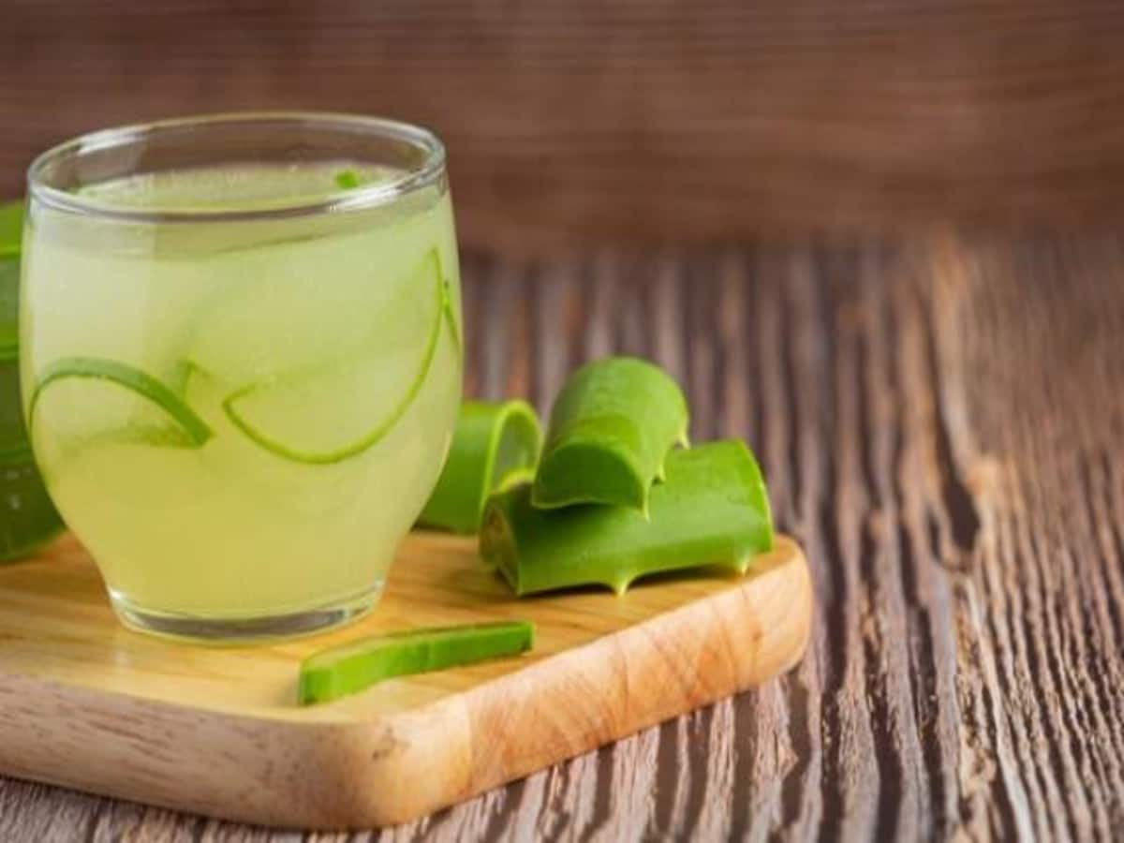
Figure 1. Aloe vera L. juice.

LITERATURE REVIEW

Plant
The botanical name of Aloe vera is Aloe barbadensis miller. It belongs to Asphodelaceae (Liliaceae) family and pea- green color plant. It grows mainly in the dry regions of Africa, Asia, Europe and America. In India, it is found in Rajasthan, Andhra Pradesh, Gujarat, Maharashtra and Tamil Nadu.

Aloe Vera Leaf Characteristics

Physical Structure of Aloe Vera Leaf
The Aloe Leaf consists of three layers:
- The outer thick rind
- A viscous, jelly like mucilage layer into which the vascular bundles, attached to the inner surface of the rind, protrude.
- The fillet proper, which has structural integrity consisting of hexagonal structures containing the fillet fluid. This is the water storage area for the plant.⁽¹⁰⁾

Active Components with Its Properties
Aloe vera contains 75 potentially active constituents: vitamins, enzymes, minerals, sugars, lignin, saponins, salicylic acids and amino acids.⁽⁴⁻⁵⁾
- Vitamins: It contains vitamins A, C and E, act as antioxidants. It also contains vitamin B12, folic acid, and choline. Antioxidant neutralizes free radicals.
- Enzymes: It contains enzymes like aliiase, alkaline phosphatase, amylase, bradykinase, carboxypeptidase, catalase, cellulase, lipase, and peroxidase. Bradykinase helps to reduce excessive inflammation when applied to the skin topically, while others help in the breakdown of sugars and fats.
- Minerals: It provides calcium, chromium, copper, selenium, magnesium, manganese, potassium, sodium and zinc. They are essential for the proper functioning of various enzyme systems in different metabolic pathways and few are antioxidants.
- Sugars: It provides monosaccharides (glucose and fructose) and polysaccharides: (glucomannans/polymannose). These are derived from the mucilage layer of the plant and are known as mucopolysaccharides. The most prominent monosaccharide is mannose-6-phosphate, and the most common polysaccharides are called glucomannans [beta-(1,4)-acetylated mannan]. Acemannan, a prominent glucomannan has also been found. Recently, a glycoprotein with antiallergic properties, called alprogen and novel anti-inflammatory compound, C-glucosyl chromone, has been isolated from Aloe vera gel.^{6, 7}
- Anthraquinones: It provides 12 anthraquinones, which are phenolic compounds traditionally known as laxatives. Aloin and emodin act as analgesics, antibacterials and antivirals.
- Fatty acids: It provides 4 plant steroids; cholesterol, campesterol, β-sisosterol and lupeol. All these have anti-inflammatory action and lupeol also possesses antiseptic and analgesic properties ⁸⁻⁹

Activity of Aloe Vera as Antidiabetics
Many explanations were suggested for this antidiabetic effect of aloe. The first explanation is the potent antioxidant effect of aloe extract. Aloe is long known to have antioxidant potential via suppression of free radical formation and enhancement of cellular thiol status. It is also reported to stimulate glutathione-S-transferase enzyme activity. That is, oxidative stress is involved as a causative factor in the pathogenesis of diabetes, and hence antioxidants like aloe may have a true antidiabetic effect via antioxidant potential ⁽¹⁰⁾.

Plant Structure and Active Components
Delving into the physical structure of Aloe vera leaves, the intricate three-layered composition comprising the outer thick rind, viscous mucilage layer, and fillet proper is elucidated. Computational models are employed to depict these layers in a three-dimensional space, offering a dynamic visualization of the plant's anatomy This advanced representation facilitates a comprehensive understanding of how the plant stores water and vital constituents.

A crucial aspect of Aloe vera's efficacy lies in its active components, including vitamins, enzymes, minerals, sugars, anthraquinones, and fatty acids. Utilizing computational biology, we analyze the structural and functional properties of these components, unraveling their synergistic roles in conferring Aloe vera's antidiabetic potential. Detailed molecular modeling showcases the interactions between Aloe vera constituents and cellular targets, shedding light on the mechanisms underpinning its therapeutic efficacy.

MATERIALS AND METHODS:

Collection of Raw Materials
Aloe vera was collected in May 2018, in the municipality of Armadillo, San Luis Potosí. A specimen was taken to the herbarium of the Autonomous Metropolitan University for future reference (specimen number ARC-53578).

Processing of Aloe Vera
Three hundred grams of the whole leaf was dried and pulverized in a mechanical mill, obtaining 110 g of dry weight. The powdered material was extracted with 3 L of methanol using a Soxhlet apparatus. The extract (AVM) was filtered and concentrated by a rotary vacuum evaporator for the complete removal of solvents ⁽¹²⁾.

DISCUSSION
In this study, we emphasize the vital role of Aloe vera's active constituents, such as vitamins, enzymes, minerals, sugars, anthraquinones, and fatty acids, in its efficacy. Leveraging 3D computational biology, we unravel the structural and functional attributes of these components, elucidating their collaborative functions in bestowing Aloe vera with potent antidiabetic properties. Advanced molecular simulations unveil how Aloe vera enhances insulin sensitivity, promotes glucose uptake in peripheral tissues, and acts on key metabolic pathways. Additionally, our computational analyses shed light on Aloe vera's antioxidative potential, illuminating its ability to counter oxidative stress—an integral factor in diabetes onset and progression. The three-dimensional molecular visualization underscores how Aloe vera's antioxidants effectively combat free radicals and bolster cellular thiol status, collectively contributing to its promising antidiabetic attributes

CONCLUSIONS
In conclusion, this comprehensive review amalgamates traditional knowledge and modern computational advancements to unveil the multifaceted potential of Aloe vera in diabetes management. The integration of 3D computational biology allows for a profound exploration of Aloe vera's intricate plant structure, active components, and antidiabetic properties. This interdisciplinary approach paves the way for future research, presenting novel opportunities to harness Aloe vera's therapeutic attributes for combating diabetes and advancing human health.

REFERENCE
- Haghani F, Arabnezhad MR, Mohammadi S, Ghaffarian-Bahraman A. Aloe vera and Streptozotocin-Induced Diabetes Mellitus. Rev Bras Farmacogn. 2022; 32(2):174–187.
- Sánchez M, González-Burgos E, Iglesias I, Gómez-Serranillos MP. Pharmacological Update Properties of Aloe Vera and its Major Active Constituents. Molecules. 2020 Mar 13;25(6):1324.
- Deora N, Venkatraman K. Aloe vera in diabetic dyslipidemia: Improving blood glucose and lipoprotein levels in pre-clinical and clinical studies. J Ayurveda Integr Med. 2022 Oct-Dec;13(4):100675.
- Abid Aslam Maan, Akmal Nazir, Muhammad Kashif Iqbal Khan, Tahir Ahmad, Rabia Zia, Misbah Murid, Muhammad Abrar, The therapeutic properties and applications of Aloe vera: A review, Journal of Herbal Medicine, Volume 12, 2018, Pages 1–10.
- Surjushe A, Vasani R, Saple D G. Aloe vera: A short review. Indian J Dermatol 2008;53:163–6.
- Purohit SK, Solanki R , Soni MK , Mathur V. Experimental evaluation of Aloe vera leaves pulp as topical medicament on wound healing. IJPR, 2012; 2: 110–12.
- Agarwal A, Dwivedi N. Aloe vera: Magic or myth . SRM J Res Dent Sci 2013;4:119–24.
- Amira Mourad Hussein Abo-Youssef, Basim Anwar Shehata Messiha, Beneficial effects of Aloe vera in treatment of diabetes: Comparative in vivo and in vitro studies, Bulletin of Faculty of Pharmacy, Cairo University, 2013, 51(1):7–11.
- V. K. Chandegara1, A. K. Varshney, Aloe vera L. processing and products: A review ,Int. J. Med. Arom. 2013,3(4): 2249–4340.
- Alethia Muñiz-Ramirez , Rosa M. Perez, Efren Garcia, Fabiola E. Garcia, Antidiabetic Activity of Aloe vera Leaves, Evidence-Based Complementary and Alternative Medicine,2020, Article ID 6371201.

