Comprative Studied Oxidation and hot corrosion behaviors of uncoated and detonation gun sprayed Cr₃C₂-25NiCr coating on SA516 boiler steel at 800°C
¹Anil Kumar, ²Vivek Srivastava, ³N.K. Mishra
¹School of engineering, Babu Banarasi Das University, Lucknow, India-226028
²School of engineering, Babu Banarasi Das University, Lucknow, India-226028
³ Babu Banarasi Das Northern India Institute of Technology, Lucknow, India-226028

Email: anilbbd16@gmail.com

Abstract
In the present investigation Cr₃C₂-25NiCr powder was deposited on boiler steel SA 516 (Grade 70) by detonation gun process. The oxidation & hot corrosion performance of coated as well as bare boiler steel was studying in the air and aggressive environment of Na₂SO₄–50% NaCl under cyclic conditions at an elevated temperature of 800⁰C. Oxidation and hot corrosion of metals and alloys has been recognized as a serious problem for elevated-temperature applications such as boilers, gas turbines, fluidized bed combustion and industrial waste incinerators. At the present conditions, problems of component materials reliability in power plant concentrate on assessing the potential behavior of coatings, in order to avoid expensive failure in service .The kinetics of the corrosion were examined by the weight change measurements made after each cycle for a total period of 50 cycles. Each cycle consisted of 60 minutes heating in a silicon wire tube furnace followed by 20 minutes cool about ambient air. The thermo-gravimetric technique was used to establish oxidation kinetics and Scanning Electron Microscopy /Energy Dispersive Spectrometry (SEM/EDS) techniques were used to analyze the corrosion products. Both the uncoated boiler steels suffered intensive spallation in the form of removal of their oxide scales, which may be attributed to the formation of unproductive Fe₂O₃
dominated oxide scales. Cr₃C₂-25NiCr coated boiler steel consists of granules structure, which appear to be interconnected with each other at most of the places and forms oxide of chromium, which has found to be good corrosion resistance to both environments.
Keywords: Detonation-Gun, Elevated temperature, SA-516 (grade-70), Cr₃C₂-25NiCr coating, SEM/EDS morphology

1. INTRODUCTION
The ongoing development in the material is intended for the elevated temperatures applications in order to facilitate to check on the degradation under the increased operational temperature of boiler tube, development and cool schemes will lead to increased operation temperatures of gas turbines, boilers, and industrial waste incinerators. The major power plants are suffering from corrosion problem with elevated temperature [1].Such problem cannot remove completely, but it is finding that

corrosion related costs can optimize up to 25% with the help of best oxidation and hot corrosion control techniques [2].Hot corrosion is a serious problem which exists mainly on the part of superheater in coal fire boiler. These formations of large amount of corrosion, due to the combustion of coals which contained excessive amount of chlorine are reported [3-6].All literature publish the wide help of all researchers of thermal sprayed coatings for the prevention of boiler and gas turbine against oxidation and hot corrosion problem [7-8].Cr₃C₂-25NiCr coatings are better stability, microstructure as compared to other coatings. The D-gun method offers the highest velocity (600-1200 m/s) for sprayed powders that are not obtained by plasma (400 m/s) and high velocity oxy-fuel (500 m/s) [9].The main objective of this work is to investigate the high temperature oxidation and hot corrosion behavior of Detonation gun sprayed Cr₃C₂-25NiCr coatings in presence of air and salt at 800⁰C temperature. The experiments were conducted for 50 cycles, each cycle heating the sample an hour and followed by cooling 20 minutes under cyclic process.
2. Experimental
2.1 Material and coating formulation
Table-1
Chemical composition (wt %) | C | Mn | P | S | Si | Fe
SA516 (Grade 70) | 027 | 0.85- 1.2 | 0.035 max | 0.035 max | 0.13-0.45 | Balance

ASTM-SA516 (Grade 70) boiler steel has been chosen as substrate materials as they are used in the boiler and gas turbine component because of their high strength and creep resistance at high temperatures. Specimen each measuring 20 mmx15 mmx5 mm approximately was cut, polished by using emery papers of 220,400,600 grit sizes and subsequently grit-blasted with the alumina particles of grit size 40 after that deposition of the Cr₃C₂-25NiCr coating was done by detonation gun spraying technique. The nominal chemical composition as shown in table1.
2.2 Development of coating
Commercially available Cr3C2-25NiCr powders having particles size 30-60 µm size (M/S H.C.
Stars Company, Germany) were deposited on substrate by Detonation gun method at XVX Powder M Surface Engineering Pvt.Ltd, Noida (India).All the process parameters were kept constant throughout the coating process.
Oxygen Flow rate | 2800 SLPH
C₂H₂ | 600 SPLH
N₂ | 2400 SPLH
Spray distance | 165 mm
Frequency of slots | 3

Table.2. Thermal spray parameter used for detonation gun coating
SPLH: standard Liters per Hour

2.3. Characterization of as-sprayed Coating
The Cr₃C₂-25NiCr coating has been characterized with the help FESEM and EDS analysis. This microscopy was used to measure the porosity of sprayed coating. Scanning Electron Microscopy (SEM 430 model LEICA electron optix unit, England) was used to characterize the surface morphology of the as sprayed Cr₃C₂-25NiCr coating and Energy Dispersive Spectroscopy (EDS) was used to characterize the formation of oxide scales at particular surface area of the sample.

2.4 High Temperature Oxidation Experiment
The studies were conducted at 800°C using silicon wire tube furnace having PID temperature controller. The samples were polished, which will provide uniformity of reaction while oxidation process occurs. Then dimensions measured by digital vernier calipers to calculate surface area which required for plotting of graph of weight gain per unit area verses number of cycle. Finally specimens were cleaned i.e. degrease by ethanol and kept in alumina boat. This alumina boat prior to performing of experiment was kept in silicon wire tube furnace for 5 hours at 250⁰C and then kept in furnace at 800⁰C for two hours so that moisture is totally removed from boat. After that the sample was kept in boat and weight was taken initially and then placed in the furnace. Oxidation and hot corrosion behaviors of bare and coated steel SA516 has been investigated in oxidizing and salty environments under cyclic conditions at 800⁰C for 50 cycles. Each cycle specimen heating one hour at 800°C in silicon wire tube furnace followed by 20 minutes cool at room temperature and their weight was taken by electronic balance (Make Contech, India) having sensitivity of 0.001 gms. Spalled scale was also taken into consideration which used to fall into the boat i.e. the weight was taken along with the boat.

3. Result and Discussion
3.1 Weight Change Analysis- Fig.1(a) shows that weight gain of both uncoated and coated samples in presence of air (25.5mg/cm²,15.2mg/cm²) and weight gain of both uncoated and coated in presence of salty atmosphere Na₂SO₄-50% NaCl (32.85mg/cm²,20.5mg/cm²).
Fig.1(b) shows the square graph of weight gain/area against number of cycle which denotes the parabolic rate of reaction(K_{p}).The values of K_{p} are based upon the parabolic rate equation for high temperature oxidation process given by- y² = (K_{p} x t) + constant, where y be the weight change per unit surface area,t be the time ,and K_{p} denoted the parabolic growth rate constant. The value of K_{p} for
uncoated and coated in presence of air were found 1.6x 10⁻¹⁰ g²cm⁻⁴ s⁻¹, 0.3x 10⁻¹⁰ g²cm⁻⁴ s⁻¹ and the value of K_{p} for both uncoated and coated samples in presence of salty atmosphere were found 3.2x 10⁻¹⁰ g²cm⁻⁴ s⁻¹, 0.8x 10⁻¹⁰ g²cm⁻⁴ s⁻¹.

Figure.1.(a)

Figure.1(b).

Fig.1.Shows that weight change/area vs number of cycle in fig1.(a) and fig.1(b) shows [weight change/area]² vs number of cycle ,for uncoated and coated with Cr₃C₂₋25NiCr coating at 800⁰C for air and salty atmosphere for 50 cycles.

3.2 EDS - The energy dispersive spectrometer analysis fig.3(a), fig.(b),fig.3(c) & fig.3(d) shows peak of Fe,Cr,Ni,Cu,Mn ,Zn,Si in both cases of coated and uncoated at 800⁰C in presence of air and salt.
The uncoated sample in presence of air and salty environment, formation of Fe peaks dominates but in coated samples with Cr₃C₂-25NiCr sprayed coating by detonation-gun method, Cr, Ni, Mn peaks generated in major scale.

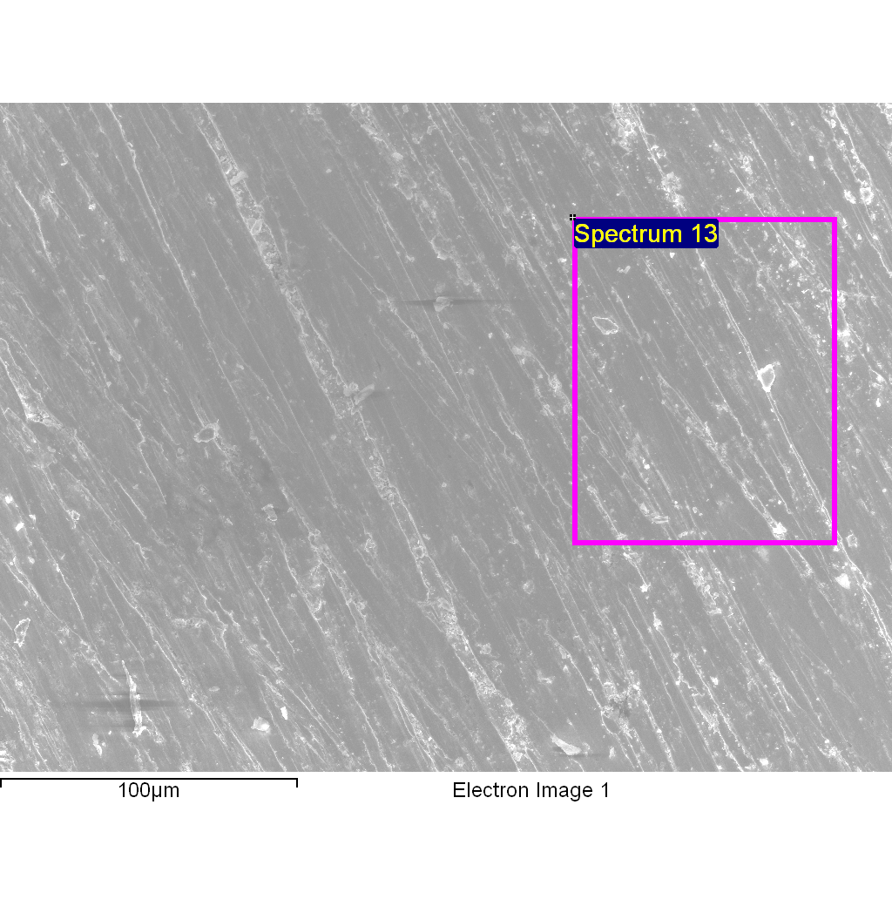
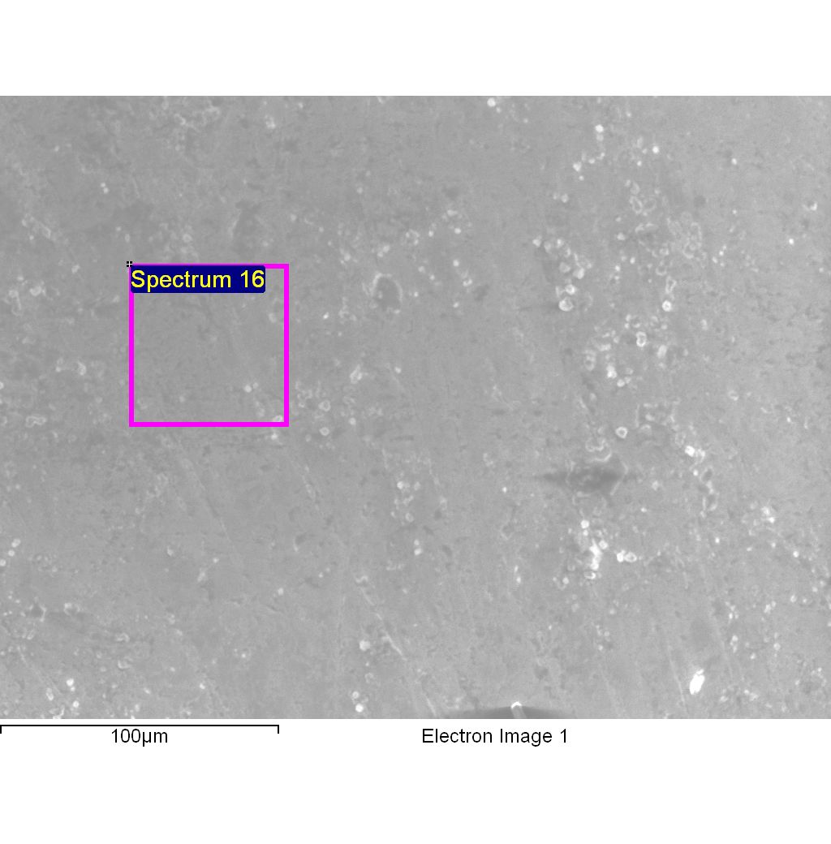

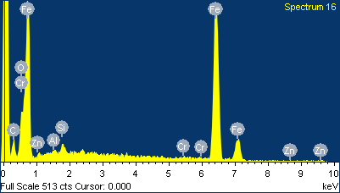
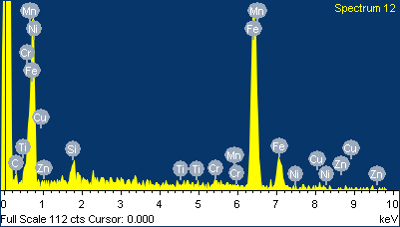

(a) (b)
Fig.3 Shows EDS patterns of (a) uncoated (b) coated with Cr₃C₂-25NiCr, in presence of air on boiler steel SAE-516 at 800⁰C

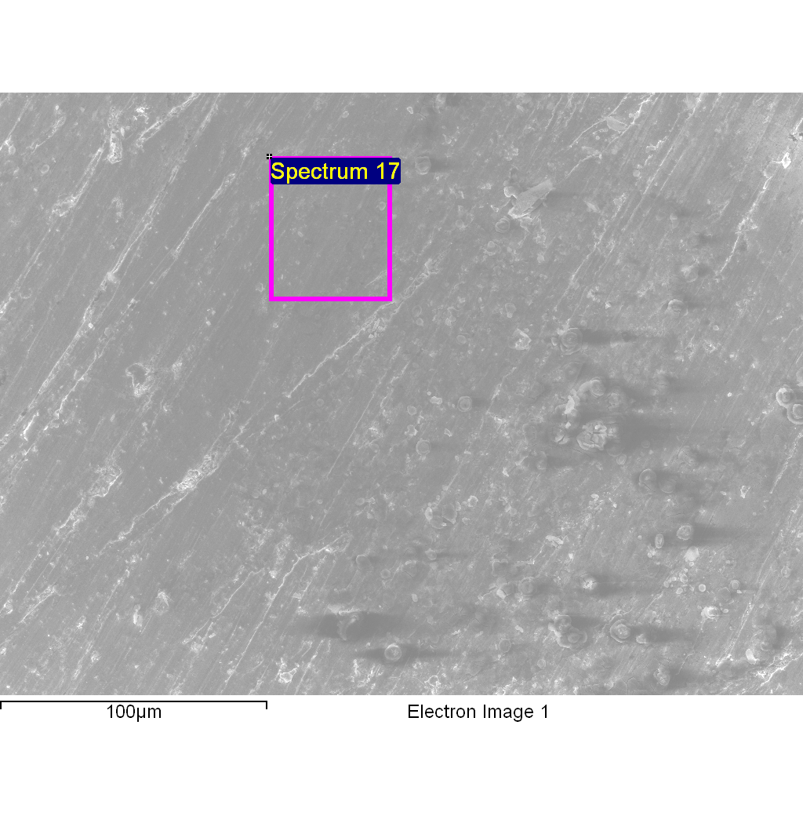
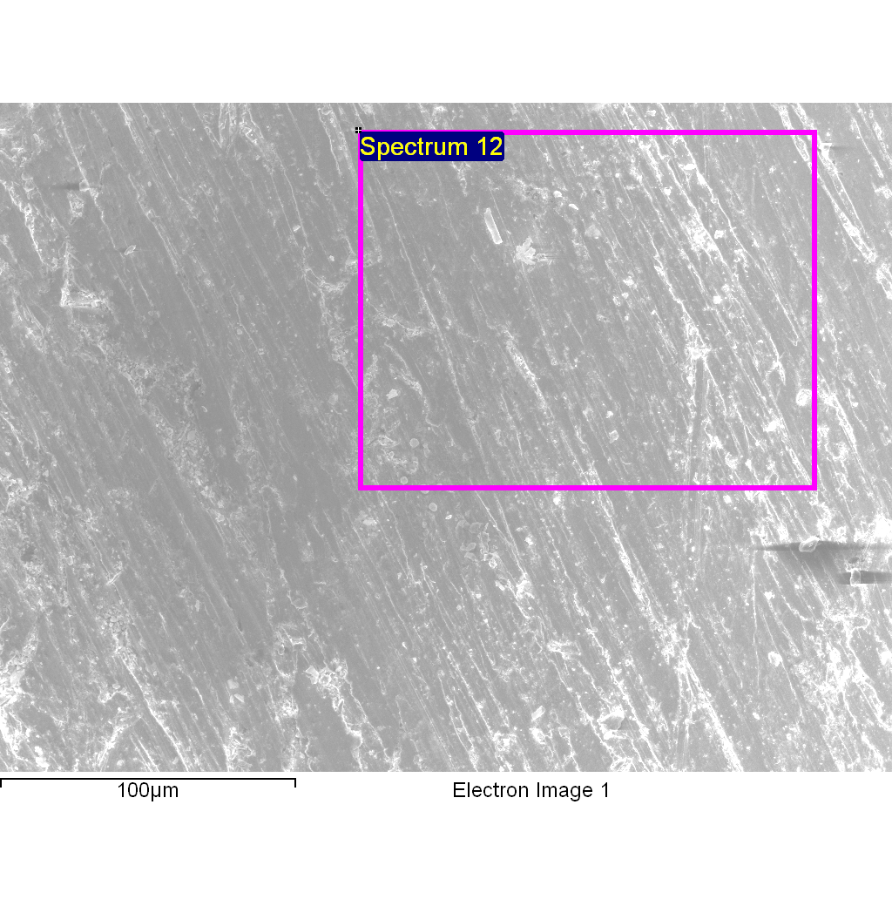

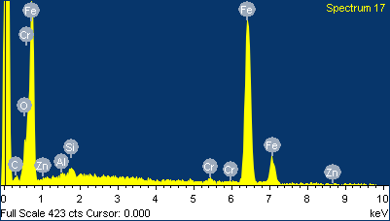
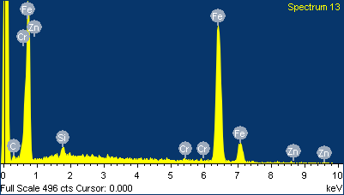
(c) (d)

Fig.3 Shows EDS patterns of (c) uncoated (d) coated with Cr₃C₂-25NiCr,in presence of salty environment (Na₂SO₄+ 50%NaCl),on boiler steel SAE-516 at 800⁰C.

3.3 SEM (Scanning Electron Microscopy)-

(a) (b)
(c) (d)

Fig.4. SEM micrographs of (a) SAE-516 uncoated with air b) SAE-516 coated with air (c) SAE-516 uncoated with salt (d) SAE-516 coated with salt, subjected to Na₂SO₄ -50% Nacl at 800⁰C for 50 cycles.

FE-SEM analysis of the scale formed after 50 cycles of the oxidation and hot corrosion in air and salt environments at 800⁰C on SAE-516 boiler steel .The upper layer has cloudy structure, with irregular sized cloud dispersed in the structure in Fig.4 (a) which has major space for the absorption of oxygen but Fig. 4(b) shows ice-berg structure, which has sufficient space for the absorption of oxygen. In salty atmosphere (Na₂SO₄ -50% NaCl),uncoated upper layer has removing chips of metal in bulk space for the absorption of oxygen shows in Fig.4(c) ,but in coated structure Fig.4(d) consists of Granules, which appear to be interconnected to each other at most of the places.Some places were found the black matrix like structure. The scale mainly has Cr and O as its main constituents. The uncoated boiler steel suffers from a catastrophic degradation in the form of intense spalling of scale in both the environments but Cr₃C₂-25NiCr sprayed coating showed good adherence to the boiler steel during the exposure with no tendency for spallation of its oxide reported by M.Kaur et.all [10]& Manpreet Kaur et.all[11].Based upon the above discussion & results of the present study. It may be concluded that the detonation- gun spray Cr₃C₂-25NiCr coating could be useful to impart high-temperature oxidation and hot corrosion resistance to be given boiler steel.

4. Conclusions

- Cr₃C₂-25NiCr coating could be deposited on SAE-516 boiler steel by D-gun spray technique and the value of K_{p} for uncoated and coated in presence of air were found 1.6x 10⁻¹⁰ g²cm⁻⁴ s⁻¹, 0.3x 10⁻¹⁰ g²cm⁻⁴ s⁻¹ and the value of K_{p} for both uncoated and coated samples in presence of salty atmosphere were found 3.2x 10⁻¹⁰ g²cm⁻⁴ s⁻¹, 0.8x 10⁻¹⁰ g²cm⁻⁴ s⁻¹.
- The Cr₃C₂-25NiCr sprayed coating was found to have ice-berg structure in presence of air and granular structure in presence of salty environment.
- Uncoated SAE-516 steel suffered from accelerated oxidation and hot corrosion in the form of intense spalling of the scale during the oxidation and hot corrosion studies with a significant overall weight gain. During the exposure to the actual boiler environment at 800⁰C ± 10⁰C, the steel suffered from higher weight gain in comparison with its coated counterpart.
- The Detonation-gun spray Cr₃C₂-25NiCr coating was found to be successful in maintaining its excellent adherence on the boiler steel in both envoirements.The coated SAE-516 boiler steel showed better oxidation and hot corrosion resistance in comparison with its uncoated counterpart.
References
- Manpreet Kaur., Harpreet singh., Satya Prakash, Surface engineering analysis of detonation-gun sprayed Cr3C2-NiCr coating under high-temperature oxidation and oxidation–erosion environments, Surf. Coat. Technol. 206 (2011) 530-541.
- Buta Singh Sidhu, S. Prakash, “Studies on the behavior of stellite-6 as plasma sprayed and laser remelted coatings in molten salt environment at 9000C under cyclic conditions” Journal of Materials Processing Technology 172 (2006) 52–63.
- S. Collins, Biomass-fired plants face down near-term challenges, Power137 (1993) 51–53.
- H.P. Nielsen, K. Dam-Johansen, L.L. Baxter, Progress in Energy and Combustion Science 26 (2000) 283-298.
- B. Q. wang, Effect of alkali chlorides on erosion-corrosion of cooled mild steel and Cr3C2-NiCr Coating, wear 199 (1996) 268-274.
- B. Wang, Erosion-corrosion of thermal sprayed coatings in FBC boilers,Wear 199(1996) 24-32.
- S. Kamal, R. Jayaganthan, S. Prakash, Evaluation of cyclic hot corrosion behaviour of detonation gun sprayed Cr3C2–25%NiCr coatings on nickel- and iron-based superalloys Surface andCoatings Technology, 203, (2009), 1004-1013.

- S. Kamal, R. Jayaganthan, S. Prakash, High temperature oxidation studies of detonation-gun sprayed Cr3C2–NiCr coating on Fe- and Ni-based superalloys in air under cyclic condition at 900⁰C, Journal of Alloys and Compounds 472 (2009) 378–389.
- J.K.N. Murthy, Venkataraman, B., Abrasive Wear Behaviors of WC-CoCr and Cr3C2-20(NiCr) Deposited by HVOF and Detonation Spray Processes, Surf. Coat. Technol, 200(8) (2006)265–2642.
- Varinder Pal Singh Sidhu, Khushdeep, Goyal, Rakesh Goyal, Comparative study of corrosion behavior of HVOF-coated boiler steel in actual boiler environment of a thermal power plant, Journal of the Australian Ceramic Society, 53,(2)(2017)925–932.
- M. Kaur, H.Singh and S. Prakash, High-temperature Behavior of a High-Velocity Oxy-Fuel Sprayed Cr3C2-NiCr Coating, Metallurgical and Materials Transactions A 43 (A) (2012) 2979-2993.

